VisaGuide: The Key to International Student Recruitment

Jeremy A. Hadley

Indiana University Purdue University Indianapolis

# Author Note

Jeremy A. Hadley, School of Informatics & Computing, IUPUI

Correspondence concerning this paper should be addressed to Jeremy Hadley, 4437 Mayapple Ct, Indianapolis, IN 46203. Contact: jahadley@iu.edu

# Table of Contents

1. Abstract……………………………………………………………………………. 3
2. Introduction………………………………………………………………………… 4
3. Problem Research………………………………………………………………….. 4
   1. Increasing Expenditures……………………………………………………. 5
   2. Decreasing Enrollment……………………………………………………...6
4. Solutions Research…………………………………………………………………. 7
   1. Decreasing Expenditures…………………………………………………....8
   2. Increasing Non-Tuition Funding……………………………………………8
   3. Increasing Enrollment……………………………………………………… 9
      1. Exploring Domestic HS & Graduate Students……………………...9
      2. Exploring Domestic Returning & Adult Students………………….10
      3. Exploring International Student Populations……………………….10
5. Solution Exploration………………………………………………………………..13
   1. Stakeholder Interviews……………………………………………………...13
      1. Interview with Melissa Rudd……………………………………….13
      2. Interview with Mark Astrom………………………………………..15
      3. Interview Reflection………………………………………………...18
   2. Similar Products…………………………………………………………….18
   3. Required Features…………………………………………………………...20
   4. Application Walkthrough……………………………………………………20
      1. Student user account setup………………………………………….20
      2. Two-way messaging between institution & student………………...21
      3. Program and school search function………………………………..23
      4. Applying for admission to chosen universities……………………..25
      5. Acceptance and beginning the visa lifecycle……………………….27
   5. Future Releases……………………………………………………………..29
6. Conclusion………………………………………………………………………......30
7. References…………………………………………………………………………..32
8. Appendix A - Interview Transcripts…...…………………………………………....34
9. Appendix B - Link to Application Mockups………………………………………..40

# 

# 

# Abstract

# This paper explores the viability, design, and functionality of a new product to assist colleges and universities to recruit international student populations. Much of the research to determine the demand for such a product was conducted using information regarding the number of student visas issued over the past several years from government sources. In addition, information was gleaned from the National Center for Educational Statistics (NCES) to show the changes in post-secondary educational enrollment numbers over the years. This paper examines similar technology currently on the market and addresses the need for changes to adapt to the current technological climate.

# *Keywords:* student visa, international education, international recruitment, software as a service, SaaS

# 

# 

# 

# 

# 

# 

# 

**VisaGuide: The Key to Global Education**

Colleges and universities today face a difficult challenge in maintaining a level of funding to not only meet operating expenses, but also to expand university programs, facilities, student services, and fund research. Funding for universities can come from many different sources, however many of these options are shrinking or very limited. As priority spending of state tax dollars becomes more diversified to address issues like infrastructure, healthcare, unemployment, and social safety nets, higher education should expect to see contributions from the state continue to decrease in the near future. While grant funding certainly provides a large portion of university capital, most of this funding is ear-marked for specific research. This source does little to address university expenses outside of the realm of research. Donor funding can certainly be a boon to colleges and universities, but relying on these donations as a major source of revenue can be dangerous, especially for smaller, private non-profit schools without a large alumni base. All of these factors come together to show that the key to university financial solvency is recruiting and retaining more students on an annual basis.

**Problem Research**

The issue of competition for high achieving students has always been a focus in higher education. Over the past decade, this competition has intensified due to changes in technology that have increased connectivity between schools and prospective students. In addition, statistics show that the number of students has decreased over the several years and indications are that the trend will continue. Declining enrollment, paired with the aforementioned limitations of other sources of funding are leading some institutions into dangerous financial territory. Mumper & Freeman (2005) found that struggles with enrollment, decreases in state and federal funding, and more expensive payroll are some of the major factors leading to rapidly increasing tuition and fee costs. These factors have contributed to a rapid increase in the number of degree-granting postsecondary institutions that have ceased operations over the past several years.

**Increasing Expenditures**

Over the past 2 decades, expenditures for postsecondary institutions have rapidly increased on both a per student rate and on a per institution rate. According to the National Center for Education Statistics (NCES) (n.d.), a branch of the U.S. Department of Education, expenditures have increased from just short of $190 billion in 1996 to $583 billion in 2016, the latest year for which they have statistics. While the difference in dollars is staggering, one must consider that the number of students in these institutions to get a clearer picture. In 1996, there were 14,908,352 students enrolled in degree granting schools, which would show an expenditure of $12744 per student. The same calculation for 2016 would include 19,308,000 students for a per student expenditure of $30194. (Snyder, de Bray, & Dillow, 2019, p. 461). This illustrates the exploding costs of running an institution of higher learning, with an increase of 137% in expenditure per student.

The increase in spending can be attributed to a combination of several different factors. Based on the U.S. Bureau of Labor Statistics (n.d.) inflation calculator, 54% of the increase could simply be explained by inflation. According to the Snyder, de Bray, & Dillow (2019, p. 621), expenditure increases in several areas outpaced inflation: instructional costs (87%), research (106%), public service (110%), and academic support (122%). Based on these statistics, institutions could consider trying to cut these costs, however all of these areas are integral to the mission of universities. One of the driving factors in the changes in instructional cost is the advent of education software, which has been inextricably integrated into the curriculum for most universities. In addition, due to increasing enrollment, American universities have increased the number of faculty over the last 2 decades from 1 faculty member per 15.2 students in 1995 to 1 faculty member per 14.1 students in 2016. This obviously has an impact on the cost of providing instruction to the student population. Public service is an obvious necessity for student resume building and maintenance of private non-profit status. Academic support costs are also driven in part by advancements in technology and reporting mandates from state and federal government. Research is a major driver of grant funding, charitable donations, and often generates more revenue than it would expend. Taking these things into consideration, it would appear that there is not a clear way to approach the financial solvency issue by reducing expenditures.

**Decreasing Enrollment**

To exacerbate the expenditure issue, the Snyder, de Bray, & Dillow (2019, p. 387) reports that the number of students attending US degree-granting colleges and universities has steadily decreased from a peak of 21 million in 2010 to the most recently reported number 19.9 million in 2016 (Figure 3.1). Although the NCES (n.d.) shows an increase in the percentage of US high school graduates attending a degree-granting school, they also project that enrollment trends will remain stagnant through at least 2027. This trend, along with the increase in expenditures, come together to cause potential for financial strain on colleges and universities who struggle with enrollment. One issue impacting enrollment is the skyrocketing cost of higher education. NCES (n.d.) data shows that average total costs for students living on campus has increased from $27589 (2010-2011) to $32595 (2015-2016). This increase of nearly 18.5% over 5 academic years is making higher education less attainable for prospective students without the financial means to pay. The increasing costs certainly will not help to increase enrollment numbers and could easily lead to a decrease in enrollment as higher education becomes less affordable.

***Figure 3.1***

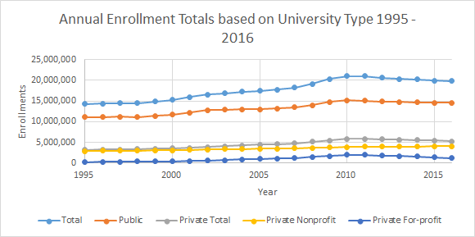

**Solution Research**

The cost of higher education is essentially shared between 4 entities; the government, parents, students, and individual or institutional donors. (Johnston, 2005) The key to any solution is determining how to increase revenue from controllable channels. Investigating ways to either address expenditure increases or enrollment decreases are integral to any viable solution. For a solution to be considered realistic, we must consider the areas of opportunity and possible limitations of a potential product.

**Decreasing Expenditures**

As previously discussed in the problem research section of this paper, the expense of operating an instituation has very steadily increased over time. This is due to the addition of student services, new techology, and the cost of research. Because many of these additions have become either inextricably linked to course offerings and curriculum management or have been added due to necessity or demand of the student body, decreasing expenditures would be a difficult path to follow for financial solvency. With learning software being a large driver of instruction expenditures and research being an indispensable part of the university mission, the opportunity for savings here is neglible.

**Increasing Non-Tuition Funding**

Unless the university has an a large lobbying budget, the ability to change the way in which the government funds education is nearly non-existent. Most universities have a fully functioning in-house development department who work to solicit donations from corporations or individuals on a daily basis. Heavily relying on charitable contributions is a risky proposition, as these donations are not guaranteed, not consistent, and may be earmarked for specific projects. One way that larger universities have produced revenue is by adding a hospital that will help to generate income and allow for research at the same time. While this may be an option for larger, research schools with a medical program, it is not a viable option for the vast majority of colleges and universities. The limited options to increase this type of funding make it an unrealistic option for most colleges and universities. This that leaves with students and parents as our areas of opportunity to increase revenue.

**Increasing Enrollment**

In order to increase enrollment, one needs to consider the areas of opportunity. When attempting to increase enrollment, universities need to consider the potential growth from several prospective student populations. The 5 major channels for enrollment are: domestic high school students, domestic graduate students, domestic adult education, domestic returning students, and international students. In this section, we will explore each of these populations to identify viable channels to increase enrollment.

**Exploring domestic high school and graduate students.** Based upon the previously cited statistics, it does not seem that there will be enough change in domestic high school student enrollment to ensure the level of growth that is required to maintain financial solvency. With the expectation that domestic enrollment will remain stagnant for nearly the next decade, universities must approach increasing enrollment from a different avenue. Universities could attempt to drive enrollment increases through graduate programs as an alternative. Based on statistics from the U.S. Census Bureau (2019), this push has already begun, as the percentage of people with post-baccalaureate degrees in the United States has increased from 15% in 2010 to 28.7% in 2018. This should be an encouraging trend for universities, however total enrollment in postsecondary education has steadily decreased during this same time period. Institutions should definitely continue efforts to push domestic students into graduate programs, but this area may already be nearing maximum capacity, with the percentage of the population with graduate degrees growing to more than half the percentage of those with an undergraduate degree. It appears that traditional, domestic student populations do not have a great deal of opportunity for growth.

**Exploring domestic returning and adult students.** Returning and adult students are populations that have received some attention from university marketing efforts in recent years. At IUPUI, there is a marketing effort to bring adult students who previously attended, but did not graduate, back to campus. The efforts are being driven by the Degree Completion Office and the aim is to convince students to return to earn a degree. (IUPUI, n.d.) By providing these students with flexible programs, the aim is to drive enrollment and confer additional degrees. With programs like this in place, it seems that efforts are being made to target this student population to increase enrollment.

**Exploring international student populations.** One way that universities can impact the factors that are plaguing them with meeting enrollment goals is increasing the number of international students that it recruits and enrolls. The benefit of increased international student enrollment would be three-fold: increased revenue for the institution, bringing more awareness of the university to foreign countries, and increasing enrollment without contributing to the student debt crisis. International students could be a path to replace some of the revenue that used to be generated through state and federal government programs by providing additional dollars from tuition, fees, and housing. The increased revenue can be used to help maintain current levels of faculty employment, which is especially critical in research universities. Based on the research of Cantwell (2015), while international undergraduate students do not create any more revenue than domestic undergraduates on an individual basis, most universities are not currently recruiting to full capacity, so additional international students would mean increased revenue. Cantwell also notes that international graduate students do generate a slightly higher amount of revenue than domestic graduate students. Attempting to generate additional revenue from these international students can ease the cost sharing burden placed government and donors. (Johnston, 2005) Increasing brand awareness overseas could lead to additional international enrollment or greater connections for the university to provide study-abroad or international internship opportunities to students. Finally, because of the requirements placed on F-1 visa students, increasing enrollment would not lead to an increase in the mounting student debt crisis. According to the U.S. State Department (n.d.), students coming to the country on an F-1 visa must show proof of ability to pay for the entire program before being issued a visa. This ensures that the institution is bringing in people with the ability to afford the program, which is never a guarantee for domestic students. The magnitude of the opportunity to increase international student enrollment is illustrated by the most recent statistics from the United States State Department Visa Statistics report (n.d.). According to that report, the number of student visas issued has drastically decreased from a peak of 644,233 in 2015 to 362,929 in 2018 (Figure 4.1).

***Figure 4.1***

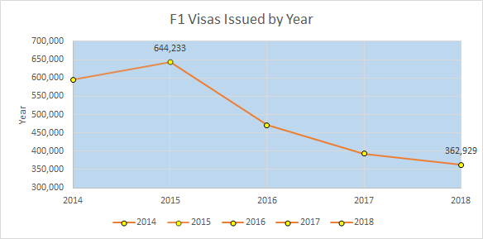

While this difference of 281,304 visas issued may only represent roughly 1.4% of the US total higher education enrollment, it represents over 7 billion dollars in tuition alone, based on the Times Higher Education (2018) analysis of tuition costs at a public university. This monetary figures would be even greater for a private university with higher tuition or when room and board are necessary for the student. While the most F-1 students ever in the U.S. was just over 644,000, there is not reason to believe that this is the maximum number of international students who could be accepted. The potential to increase international enrollment is only capped by the number of seats available at a given university for a term or by government imposed visa caps.

**Solution Exploration**

The discussion of increasing international student enrollment raises one clear question, “How?”. There are many things to be considered when designing a solution of this type. Access to technology, volatile political climates, and visa concerns should definitely be considered in any solution. The solution that I have devised is a multi-faceted application that will assist in the marketing of programs, recruitment of international students, and tracking of the student visa process. The application platform would be free to students and prospective students, however colleges and universities who wish to use the platform would be charged a fee to have access to the marketing and communication aspects of the application. The application would benefit from the increasing access to cloud computing and mobile resources around the world. According to Miniwatts Marketing Group (2019), an internet marketing research agency, 81% of the developed world has access to internet. The same report shows that there are more than 4 billion internet users outside of the United States. The application would be accessible to users though both mobile devices and consoles. The aim of this is to provide access to as many people as possible. By centralizing information about programs available to potential international students, the application would provide an opportunity for students to easily research programs of interest before ever applying to the school. If this product proves to be effective in increasing interaction and enrollment activity with international students, I believe that there could be an incredible amount of interest from colleges and universities across the U.S..

**Stakeholder Interviews**

In the process of creating an application to address issues facing international recruiters, I completed two interviews university administrators in the profession. The aim of the interviews were to better understand the student visa process and to gain some insight on topics that are causes of concern for the students. By improving my knowledge of these issues, I felt that I would be better able to address them in a way that would be desireable to our paying customer, the institution.

**Interview with Melissa Rudd.** The goal for this interview is to obtain a deeper understanding of the F-1 visa process and the student lifecycle involved. Focusing on this topic thoroughly will allow us to identify what information is most important for students to know about the visa process and assist with the way in which our information is organized. The interviewee was selected because of her extensive experience working exclusively with F-1 visa students. This interview provided real world examples of how the F-1 visa process actually works, while a literature review would only provide information about how the process should work in an ideal situation. The information could also be obtained through observation, however there are definitely some nuances that could be difficult to see if one was simply watching from the outside.

The interview subject was Melissa Rudd, who was the Designated School Official (DSO) for two different universities; Santa Fe University of Art & Design and Arizona State University. Melissa has worked in student affairs, operations, and academic advising for the past 15 years. Her role as a DSO made her responsible for tracking and updating international student information with the United States Citizenship and Immigration Services (USCIS). The interview was initially planned to be conducted via Skype, but due to scheduling conflicts it had to be conducted via email. The questions were sent to the subject on February 1st, 2019 at 8:00 am and the response was received on February 5th, 2019 at 11:00 am.

The focus of the interview was to develop the timeline for the F-1 visa process and determine some of the issues encountered by DSOs. The questions were entirely focused on the F-1 visa process and the issues that students come across during the process. Through this interview, I learned that while there are definitely steps that need to be completed for each and every student, the process has some nuance and flexibility regarding the order and timing of steps based on individual situations. One of the things that I learned, at least in regard to Melissa’s experience, DSOs do not start working with students until they are admitted to the university. From that point, the DSO will assist the student through a fairly lengthy process involving communication between the student, home country, the university, and USCIS. Initially, students must apply and be accepted to the program to begin the process. The student then provides documentation to the university, including demographic information and confirmation of resources. The university then issues and I-20 assuming that everything is approved. Then, students must arrange travel and have the I-20 approved by the consulate in their home country. When the student arrives on campus, they must check in with the international office so that the office can confirm that the student is physically present. At this time, students would need to ensure that their registration is in line with the requirements of their visa, which usually means that they are enrolled full-time. I learned through this interview that USCIS has an interface for universities to update student information. The interface is called SEVIS (Student & Exchange Visitor Program) and it is run through the Immigration and Custom Enforcement (ICE) website. DSOs must make updates to student records any time there is a relevant change to their status. This includes address changes, arrival at the university, withdraw from the university, program changes, changes in cost, and application for CPT or OPT. There are many other situations that would call for an update to a student’s USCIS record, but those are just a few. In the interview, I also asked what the most difficult part of being a DSO was and I learned the need to assist students, while staying within fairly rigid guidelines is the most difficult part of the process. Melissa stated that the best way to overcome these challenges is through solid internal processes and good recordkeeping. I also learned that DSOs need to be aware of the differences in timing between different countries. As an example, Melissa stated that students from Mexico would have visas within a day, Brazil would take at least two weeks, and Middle Eastern countries could take even longer. I also learned that political climate can cause serious complications in the process as well.

**Interview with Mark Astrom.** The goal for this interview is to obtain a cross-section of common issues from international students across various home countries. This will help us to form a frequently asked question section for our users, international students. The subject was selected based upon his experience working with international students, as a way to get a more broad perspective than could be provided by a single student. This interview provided anecdotal information that could not truly be gleaned from literature review. The information could be obtained through observation, however it would take years of observation in order to develop these insights.

The interview subject was Mark Astrom, who was the International Development Coordinator for Santa Fe University of Art & Design. Mark has worked in international student affairs for over 10 years. His role has had him in direct contact with student regarding issues from F-1 visas to finding friends on campus. In addition to his time in international student affairs, Mark has also worked as a university designated school official (DSO), so he also has an extensive background in the F-1 visa process from the administrative side. The interview was conducted on February 3rd, 2019 at 11:00 am via Skype due to distance constraints.

The focus of the interview was to get information about the most common questions asked by international students. The majority of the questions focused on student concerns and the difference between different countries when it comes to the F-1 visa process. Through this interview, I found that the two most common areas of concern for students who came into the office were questions about visa status and questions about funding. Students were most concerned with ensuring that there academic pursuits were in line with their program requirements, because the visa program requires strict adherence to the plan of study. Discussing these visa concerns also brought up the I-20, which is a document required for international travel for students utilizing the F-1 visa program. I learned that the I-20 must be certified by the university for any travel outside of the United States, even to the student’s home country. I also learned that international students are eligible for study abroad programs while they have a valid student visa. This travel must also be approved through the I-20 and the study abroad opportunity must contribute to progress toward a degree. In regards to the funding concerns, the process would vary from country to country. I learned that there are different levels of involvement from the university perspective depending on the country of origin. I learned that with Saudi Arabian students, all paperwork for funding is submitted directly from the university to the Saudi Cultural Ministry. I also learned that Norwegian students have some funding options from their home country, but it is entirely the responsibility of the student to produce the needed documents. On a related topic, we also discussed work opportunities for international students. I learned that students are eligible for on campus jobs, provided that they are not funded through the Federal Work Study program. This allows international students to have some income, as they are only allowed to work off campus in extreme situations. Finally, we had a discussion of the options available for students to extend their time in the United States following graduation. I learned that students can apply for one of 2 programs, Optional Practical Training (OPT) or Curricular Practical Training (CPT) to extend their student visas. Students who obtain job offers in the US would need to be sponsored by their employer for a work visa, the most common being the H1-B.

**Interview reflection.** The information gathered in the interviews helped to distill some of the issues that face university administrators working with international students. Learning additional information about the student visa lifecycle, processing times, and the requirements for student travel will greatly assist in building the visa timeline portion of the application. Throught these interviews, I was also able to learn that the most common concern for international students is how different actions will impact their visa status. This information will help to build the frequently asked questions page where students can go for information.

**Similar Products**

Locating similar products to my proposed web application has been difficult. It appears that most of the focus is pushing prospects into an existing Customer Relationship Manager (CRM) software. There are some similarities between the VisaGuide application and some existing CRM software systems, such as SignalVine and SalesForce Education CRM. Neither of these products has a specific focus on the recruitment of international students specifically, however some of the functionality and required features are present in both. Both offer the option to deliver personalized content to student, as well as tracking mechanisms to display where the student is in the recruitment process.

Among the existing products, there does not appear to be any sort of tracking mechanism for the student visa process. Neither SalesForce, nor SignalVine appear to have the capacity to address the specific needs of international students. Some of the features from SignalVine in particular would be extraeous to a product directed at international students, as any reference to Title IV financial aid would not apply to these students. Financial Aid appears to be an entire module in the SignalVine software. Neither of the existing product seem to offer the marketing aspect of the VisaGuide application, which would be a valuable difference. Also absent from the software is the ability for students to create an account directly on the platform. All data is collected and imported through already existing leads in the institution’s Student Information System.

SignalVine in particular has some interesting ideas that could be incorporated into future releases of the VisaGuide web application. The financial aid section could be replaced by a scholarship section that would allow international students to be offered and accept scholarships directly through the application. This would be especially useful for students who were comparing the cost of more than one university. The software also includes a “Workforce Development” module that would help students to find careers after graduation. While adding this to VisaGuide would require some modification due to issues surrounding work visas, a similar module could definitely be considered. Overall, neither of these options covers the majority of the topics addressed by the VisaGuide application. By focusing on the international student, this application will be unique in the marketplace.

**Required Features**

The first step in designing the application would be to determine the needs and wants of both international students and university personnel who would be using the application. The goal of the application would be to increase enrollment by improving the connectivity between university admissions, international offices, and faculty with prospective international students to make all steps of the transition to the United States easier for students. There are many things to consider when designing an application created to work with students from across many different countries. Cultural, linguistic, legal, geographical, and political considerations must be taken into account in order to make the application a success. Initial releases would need to focus on the more critical aspects of the international student experience (i.e. program/university selection, university application, and the visa process). These functions would be viewed as absolutely necessary by the university side, as getting the student enrolled and to campus smoothly is the number one goal of the paying customer.

**Application Walkthrough**

The goal of the application would be to simplify the user’s transition from prospective student to visa applicant to F-1 visa student. By making the information more accessible to prospective students, the application would help to drive international student enrollment for our customers, the universities. In order to achieve these goals, the design must be simple, user-friendly, and sensitive to potential language barriers. The aim would be to provide university administrators with easy to understand, actionable data on prospective students.

**Student user account setup.** The first step in the process of using the application would be setting up a student account. This would include country of origin, areas of interest, academic background, TOEFL and other related placement scores, and general demographic information. Students would be required to enter demographic information, however the depth of their profile would be optional. Students would be encouraged to include more information about themselves with messages about scholarships and recruitment from prestigious programs. All student profile information would be passed along to universities who had paid access to the application. This would allow universities to target prospective students who might be interested in one or more of their programs. From the university side, student profiles could be searched and filtered to allow for a more condensed pool of potential students (Figure 5.1). By using cloud technology, we would could positively impact performance, data security, and user experience in the application.

The information provided by the student could be used to score the student’s potential of acceptance to the university. Some additional thought went into including data like TOEFL scores in the application. While students must meet minimum TOEFL scores to be accepted into a degree-seeking program, these scores could also be used to target students for non-degree options, such as intensive English programs. This would produce more value for the customer, as they could potentially recruit a student into an intensive English program, then convert them into a degree-seeking student.

***Figure 5.1***

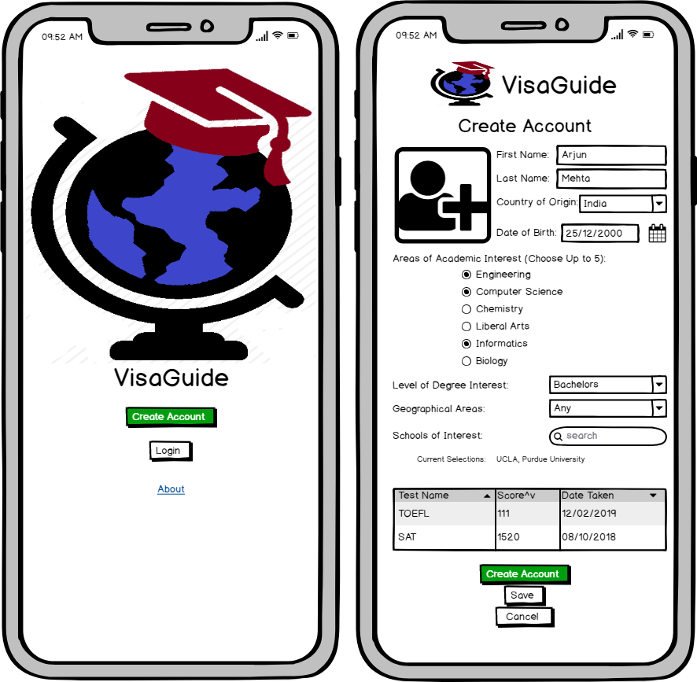

**Two-way messaging between institution and student.** The ability to send messages between prospective students and international recruiters would be a crucial aspect of the application. A secure, encrypted messaging system would be included in the application, as this could be useful at almost any point in the student’s process. Prospective students would be able to send a group message to the international office of member universities to allow for prompt response to university specific student questions. (Figure 5.2). The messaging function will be used throughout the application timeline, as students could have questions at any point in the process. Member universities could decide how they would prefer to have messages divided between international office members, whether it was by country of origin, program, or any other university defined criteria. By allowing for this sort of custom division, the application would ensure that prospective students are in touch with the university personnel best qualified to address their questions. This type of messaging would be more accessible than international text messaging or calling and would keep all school related information in one place for students better than email.

The user would have options regarding the way in which they receive messages, as the message center should be as accessible as possible. Prospective students with smart phones would be able to receive text or push notifications, while students in areas without reliable cellular service could receive the messages via email. Ensuring that direct communication can be made between the prospective student and recruiter would add a personal touch to the process. By making it easier for university officials and prospective international students to communicate, the application would remove one of the major roadblocks that often impede the recruitment of international students.

***Figure 5.2***

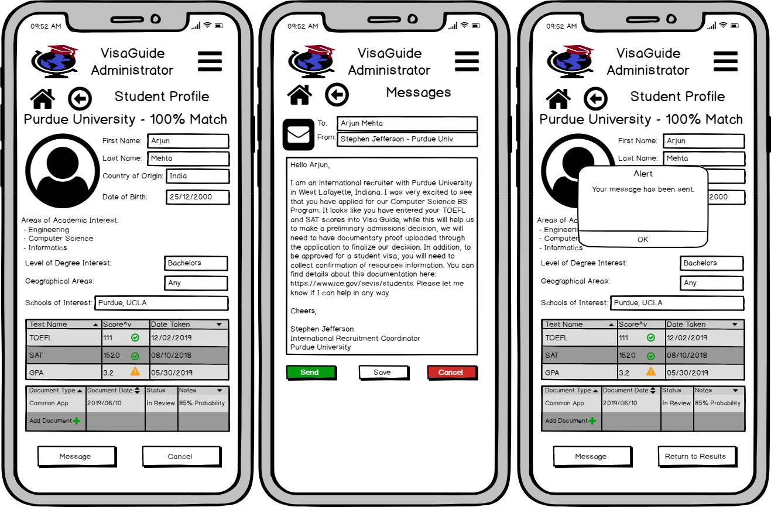

**Program and school search function.** Initially, the application would focus solely on the recruitment of international students and the steps needed to complete the visa process. In order to increase university interest in this tool, the developers would need to focus on a robust program/university research function in order to match students with potential universities and programs of interest. This feature would be especially important for smaller, lesser known schools, as it would help to heighten awareness of their programs. The search function would include multiple methods of search that could be combined to narrow down the choices for prospective students. Search options would include geographical, programmatic, demographic, cost, and prestige. Students wishing to narrow their search by any of these factors would be able to include them in their search criteria, hopefully leading to a better match between the student and school. The application would return a scored ranking of schools with a match percentage and lists of specific areas where the school matched and did not match the prospective student’s preferences (Figures 5.3.1 & 5.3.2).

This search information could also be provided to paid member schools, even if the prospective student did not include the information in their searchable profile. This would be another opportunity for universities to target students with marketing materials. Search and matching functions would also be available on the administrative side of the application. Doing this allows for recruiters to proactively contact prospective students who match the university requirements. This would be an essential part of the application, as it allows greater access to the pool of candidates.

***Figure 5.3.1 - Student School Search/Matching***

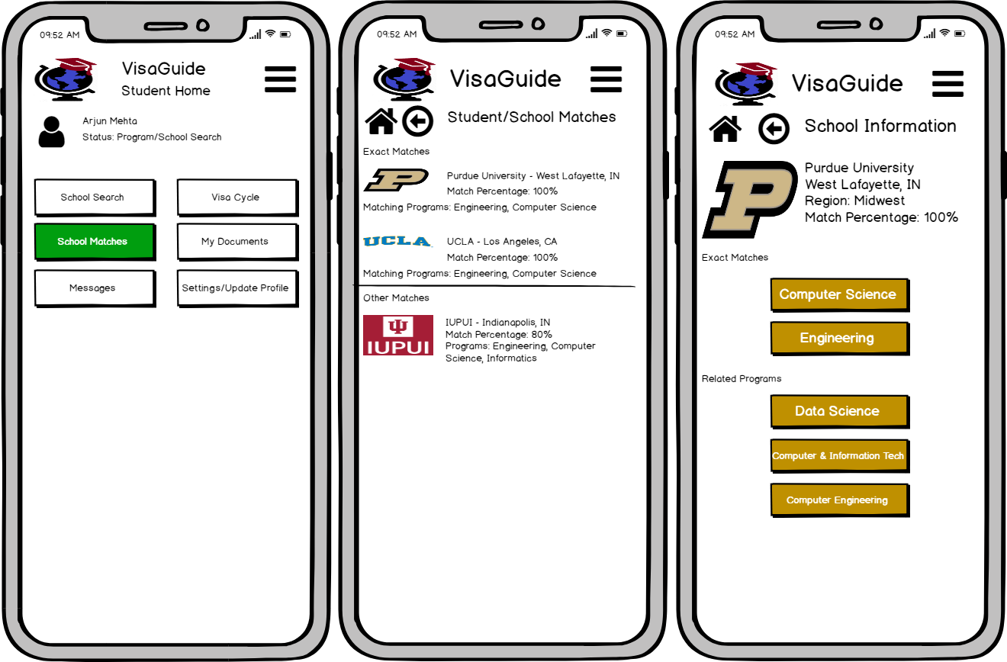

***Figure 5.3.2 - Administrator Student Search***

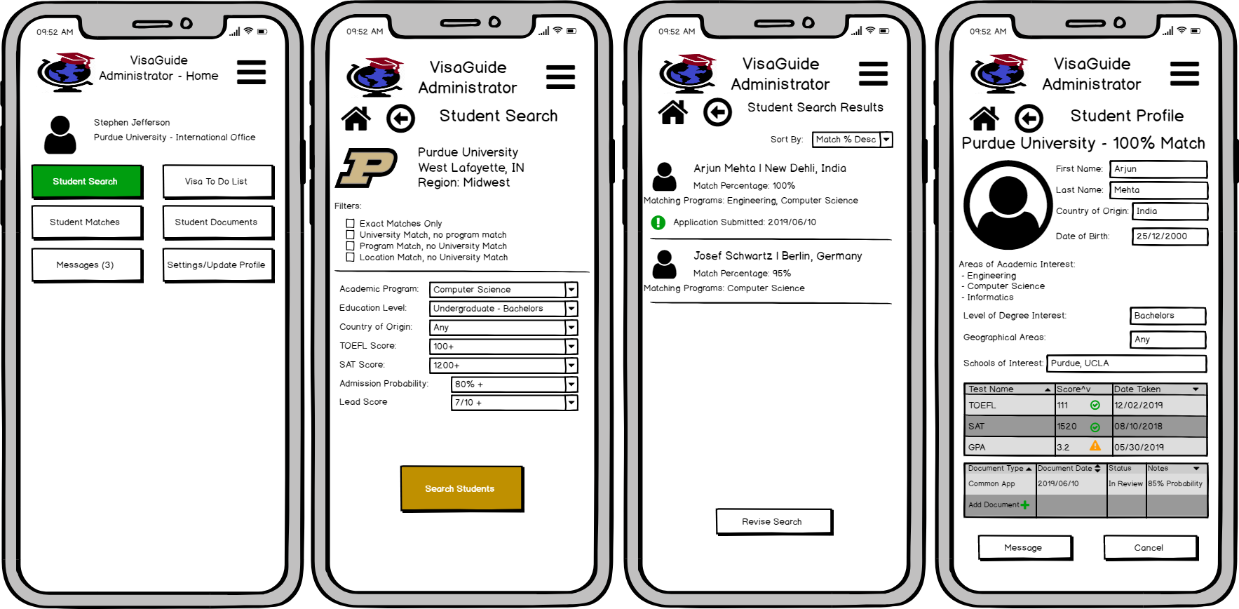

**Applying for admission to chosen universities.** The next step in the process would be guiding students to applications for their chosen school or schools. The developers would work with member universities to develop a unified application that would include any information that a school may need for the process. A single application would make the process much less tedious for students who wish to apply to multiple universities, thus removing another hurdle in the process. This would be modeled after the domestic student Common App, which is a standardized admissions application used by many US schools.

In this process, students would need to provide all information required for international students to be accepted to US schools. This would include the ability to securely upload and transfer passport and verification of assets information, as these pieces of information are required for all international students. When completing the university application, students would be notified of application fees, given links to pay, and provided with contact information for international admissions representatives from each selected school. Due to the variety of ways in which application fees can be paid, students would receive an automated message with payment information that would be written by the university in conjunction with the developers. This messaging would allow students to ask questions of university officials directly before financially committing to the application. (Figure 5.4).

Once a student submitted an application to a school, they would be assigned to a specific member of their selected school’s international team. This would allow for a more personalized experience for students as they narrow their options. Messaging directly with a single member of an international team would also ensure that the student and the representative have an understanding of where the student is in the process. Students who apply to multiple schools would have access to any of the schools to which they applied until they made a decision on which school to attend. At that point, the student would not have access to any individual contacts with other universities except their own. This direct access to the international office would continue for the duration of the student’s relationship with the university. This would allow students to easily access university officials with visa, academic, or employment questions.

***Figure 5.4***

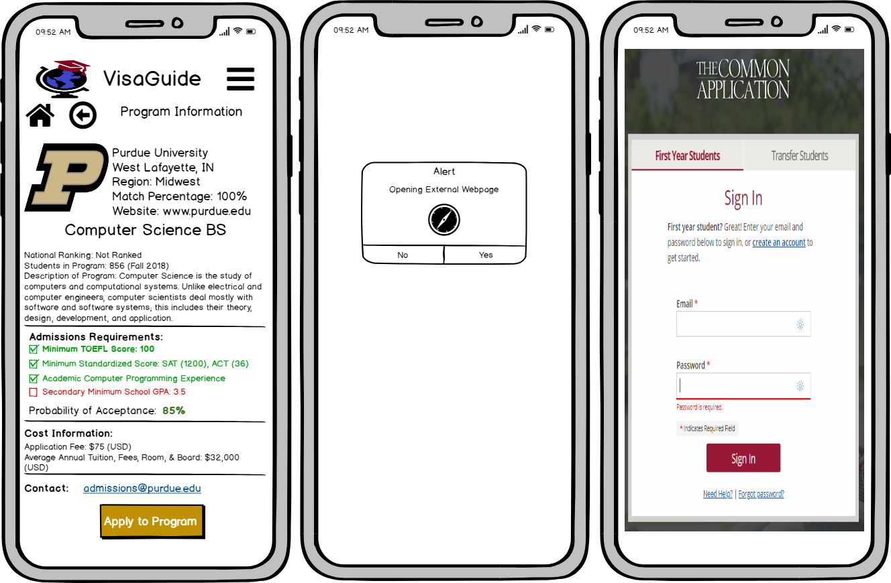

**Acceptance and beginning the visa lifecycle.** The next step in the process would be acceptance to a school or schools, followed by the students acceptance of the offer of admission. Once the student and university have agreed that the student will attend, the university provides and I-20 travel document that the student must have for the visa application process. This would begin the visa lifecycle portion of the application. This portion would include specific information about each step of the process, as well as a searchable FAQ section that would allow students to have general visa questions answered. One of the most important aspects of this section would be to use clear, plain language to describe each step. There are many resources that are already available to students about the process from Immigration and Customs Enforcement and U.S. Citizenship and Immigration, however they often include confusing language that may be difficult for a non-native English speaker to understand. By providing the information in a transparent, concise way, the application would lead students to a better understanding of the process. The student lifecycle portion of the application would be laid out as a checklist that students could update as they complete steps in the process. Each step of the checklist would provide additional information and recommended timelines that students could use at that specific point in the visa application process. Once students receive their I-20 from their university, they need to visit the U.S. embassy or consulate in their home country to complete their visa interview. The application would include detailed information on what to expect in this interview, as well as information about the consulate or embassy. This page would also include links to the Global Support Services (GSS) website for the student’s home country. The GSS website allows students to begin the visa application process and schedule their interview and is already available in many languages (Figure 5.5).

***Figure 5.5***

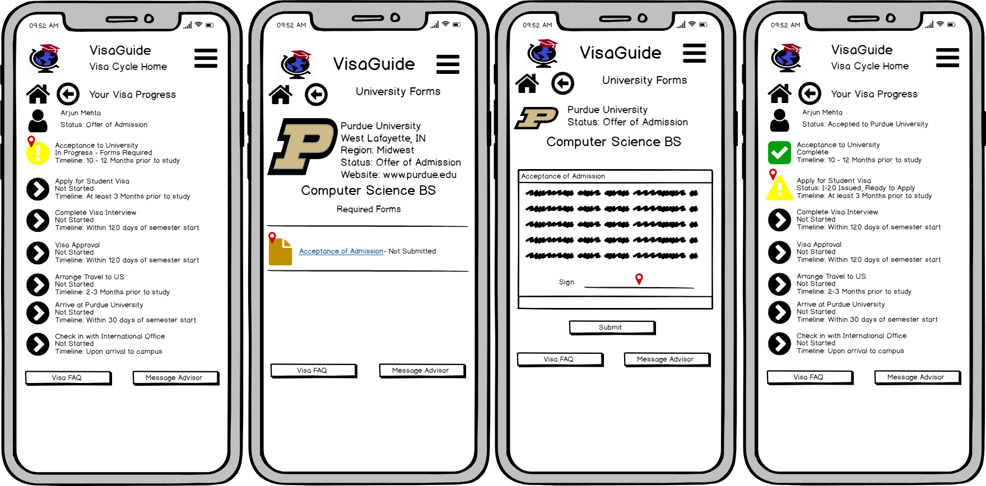

From this point in the process, the school has almost nothing to do with the student’s visa process, so the student would need to keep their checklist updated to keep university officials informed of their progress. Students would still have to option to reach out to the university with questions during this part of the process. Following visa approval, students are able to travel to the U.S. no more than 30 days prior to the start of classes. Students must provide travel information to the university, which could be securely sent through the application. Once the student arrives, the international office must verify that the student is present on campus in order to complete the initial visa cycle. Once the student has arrived on campus, the initial visa process is complete and the application’s initial purpose has been completed. The university could still use the application to send F-1 visa specific information to students throughout the school year. University administrators would be able to move a student back to a previous point in the cycle if it is needed for visa maintenance. This allows students to track their status at a moment’s notice while remaining in constant contact with university officials.

**Future Releases**

Future releases of the application could include additional modules, such as; scholarships, virutal advising, and reporting & analytics. A career services module targeted toward students who need visa sponsorship to work in the U.S. would also be a desireable addition to the application. These would add even more value to the university’s investment in this software as a service product. The possibilities for expansion outside of education in later versions would be nearly limitless, as the application would have the potential to become a full social media platform geared toward international students. These later additions could create additional revenue streams from companies or organizations wishing to advertise on the platform. These companies could include housing providers, restaurants, social clubs, car dealerships, and companies seeking interns or employees. Expanding upon the initial idea would be important to maintaining and increasing the profitability of the application.

**Conclusion**

As colleges and universities strive for higher enrollment levels, increasing marketing efforts to potential students is becoming increasingly important to university financial solvency. U.S. Government data has shown that the pool of domestic students is not growing at a nearly rapid enough rate to be a true area of opportunity. This fact drives a need for universities to recruit from the vast pool of prospective international students. With massive decreases in the number of F-1 students over the past few years, it becomes apparent that this is an area of opportunity for university recruitment. A software as a service application such as VisaGuide would greatly improve the access that universities have to overseas prospects and allow for a simplified process. The aim would be to provide students with a streamlined, easy to understand timeline of what is needed to study in the United States. The application would be a great marketing tool for schools because of its ability to extract student demographic information and academic interests. By using this application, schools would be better able to target potential students based on many factors. The application would offer direct messaging between students and university international affairs departments. This increased access would allow for a more personalized experience for students that could lead to higher enrollment of international students.

# 

# 

# 

# 

# 

# 

# 

# 

# 

# 

# References

Cabrera, Á, & Renard, C. L. (2014). Internationalization, Higher Education, and Competitiveness. *New Perspectives on Internationalization and Competitiveness,*11-16. doi:10.1007/978-3-319-11979-3_2

Cantwell, B. (2015). Are International Students Cash Cows? Examining the Relationship Between New International Undergraduate Enrollments and Institutional Revenue at Public Colleges and Universities in the US. *Journal of International Students,5*(4), 512-525.

IUPUI. (n.d.). Degree Completion Office Website. Retrieved April 3, 2019, from <https://complete.iupui.edu/>

Johnstone, D. B. (2004). The economics and politics of cost sharing in higher education: Comparative perspectives. *Economics of Education Review,23*(4), 403-410. doi:10.1016/j.econedurev.2003.09.004

Miniwatts Marketing Group. (2019). World Internet Users Statistics and 2019 World Population Stats. Retrieved April 3, 2019, from <https://www.internetworldstats.com/stats.htm>

Mumper, M., & Freeman, M. L. (2005). The Causes and Consequences of Public College Tuition Inflation. *Higher Education: Handbook of Theory and Research,*307-361. doi:10.1007/1-4020-3279-x_6

National Center for Education Statistics (NCES) Home Page, part of the U.S. Department of Education. (n.d.). Retrieved March 10, 2019, from <https://nces.ed.gov/>

Snyder, T.D., de Brey, C., and Dillow, S.A. (2019). *Digest of Education Statistics 2017* (NCES 2018-070). National Center for Education Statistics, Institute of Educational Sciences, U.S. Department of Education. Washington, DC.

Times Higher Education. (2018, May 17). The cost of studying at a university in the United States. Retrieved March 8, 2019, from <https://www.timeshighereducation.com/student/advice/cost-studying-university-united-states>

U.S. Bureau of Labor Statistics. (n.d.). CPI Inflation Calculator. Retrieved April 12, 2019, from <https://data.bls.gov/cgi-bin/cpicalc.pl?cost1=1.00&year1=199601&year2=201603>

U.S. Census Bureau. (2019, February 25). Number of People With Master's and Doctoral Degrees Doubles Since 2000. Retrieved April 3, 2019, from <https://www.census.gov/library/stories/2019/02/number-of-people-with-masters-and-phd-degrees-double-since-2000.html>

U.S. State Department. Student Visa; (n.d.). Retrieved February 08, 2019, from <https://travel.state.gov/content/travel/en/us-visas/study/student-visa.html>

U.S. State Department. Visa Statistics; (n.d.). Retrieved February 08, 2019, from <https://travel.state.gov/content/travel/en/legal/visa-law0/visa-statistics.html>

**Appendix A**

**Interview Transcripts**

Melissa Rudd

Former Designated School Official - Arizona State University

Via email Phoenix, AZ

Initially, this interview was intended to be conducted via Skype, however the subject was not available for the originally scheduled time. We chose to complete the interview via email due to our short time constraints.

|  |  |
| --- | --- |
| **Method** | Via email |
| **Time** | 10:00 AM (EST) |
| **Date** | 5 February 2019 |
| **Comments** | Answers provided are from the perspective of a designated school official |

**1. What is the typical steps in the visa process from application through graduation (and potentially to work visa or OPT if you know)?**

*“If you begin from when a student applies to a university:*

***Step 1****: admission to university > university issues I-20 - the student has to provide documents in this stage. Typically, those documents are a valid passport (must be good for at least 60 days after the program start date), and confirmation of financial resources*

***Step 2****: Once the student receives the I-20, they have to set up and complete a consulate visit in their home country. The consulate will take their passport and return it with the visa*

***Step 3:*** *The student has to register with the university international office, so the PDSO/DSO can record the student as physically present. The student would also have to ensure appropriate registration per visa requirements (typically full time enrollment)*

***Step 4:*** *Each year, if the student leaves the country, they have to check in with the university international office for a new signature on the I-20, and/or have their passport renewed if it expires. The student must also maintain sufficient enrollment in spring and fall terms (summer enrollment is typically not required by SEVIS/USCIS, and if they have experiential learning (clinical experiences or internships), they must file for CPT.*

***Step 5:*** *If the student graduates in alignment with their program date listed on the I-20, then the student can apply for OPT. They can apply for OPT up to 90 days prior to their program end date, or up to 30 days after their program end date. If their 30 day "grace" period following the program end date expires and the student has not filed for OPT, they waive that option and must leave the country.”*

**2. When is it necessary to update a student’s SEVIS record? When a registration change is made? When a housing change occurs?**

*“Any time a required field in SEVIS changes. Address changes (including housing assignments), arriving at the university, withdrawing from the university, changing programs, extending or shortening program length, changes to cost of attendance, applying for CPT or OPT, changes to registration that require a request for below full-time enrollment... and those are just what I recall off the top of my head.”*

**3. Are students able to provide information directly to SEVIS or do all changes have to pass through the DSO?**

*“SEVIS is really an interface for PDSO/DSOs to use. Students can call the SEVIS help desk if they have questions, but really most of those questions get routed to USCIS.”*

**4. What are some of the major “pain points” that you have witnessed for F-1 Visa students?**

*“Understanding when to check in with university international office, understanding when to renew their passport and/or visa, when (and how) to file for OPT, understanding the "grace" period after the program expires.”*

**5. Do you have any experience with F-2 visas for the dependents of students on F-1 visas?**

*“No, I am not familiar with F-2.”*

**6. If so, are there unique steps to this process?**

*“N/A”*

**7. What were the most difficult parts of being a DSO? What are some solutions that you think may have helped with these challenges?**

*“Honestly, I think it's about having solid internal processes and good record keeping. When I was a PDSO, we were required to have physical files for each student, but I don't know if that is still required. Being able to identify international students and where they are in relation to their program end date is important, as is the ability to easily see if they are adequately enrolled - and if they adjust their enrollment later (for example, if I pull a report on a student and they have the required 12 credits, then they drop a course and only have 9, that's a problem because "W" grades don't count towards full time enrollment).*

*Like any student service function, the actual step-by-step process can be very student and context dependent. The policies remain the same (and are almost entirely non-negotiable), but things can happen in different orders depending on the student and their situation... some students will need CPT, others won't. Some will need to extend their program end date, others won't.”*

**8. How much does the process vary depending on the student’s country of origin?**

*“The process itself is the same from country to country. Timing is different. When I was a PDSO, students from Mexico received visas next day - sometimes same day. Students from Brazil had to wait at least 2 weeks. Countries like Egypt took longer. Political climate matters, too. I had a student with dual citizenship in Saudi Arabia and Egypt, but was a Syrian national...and due to the political climate chose to get her visa through Egypt. It's important to know these things about students because if you send an I-20 with a country of origin different from where they plan to apply for their visa... you have to reissue the I-20 and re-ship it. Very expensive and wastes time.”*

**Summary**

This interview broke down the steps in the visa application process from both the student and University side. The subject provided some real world considerations for the solution and provided insight on differences between countries and how visas are processed. The subject noted that good recordkeeping is the key to success from the University side.

**Reflection**

This interview helped us to establish the timeline in the visa process from the viewpoint of the Designated School Official (DSO), who is responsible for the University side of F-1 Visa processing. It helped to reveal some of the different scenarios that can occur during the process that can be very specific based on the country of origin. It also shows that the process can be incredibly time sensitive, which also confirms that it can be an major point of stress for students. There was a lot of stress placed on recordkeeping, which could be something that needs to be incorporated into the University side of the application.

Mark Astrom

International Development Coordinator - Santa Fe University

Santa Fe, NM

Initially, this interview was intended to be conducted via Skype, however the subject was not available for the originally scheduled time. We chose to complete the interview via email due to our short time constraints.

|  |  |
| --- | --- |
| **Method** | Face to Face, via Skype |
| **Time** | 11:00 AM (EST) |
| **Date** | 3 February 2019 |
| **Comments** | Interview was recorded and answers were transcribed. |

**1. What are some of the most pressing issues facing students who are in the US on an F-1 student visa?**

*“It depends on the student, but ranges from small concerns about choosing courses to large concerns, such as how to get their family approved to come to the US as well. The most common issue encountered was making sure that students were in courses that would count toward their degree. There is very little wiggle room for F-1 students with electives, so sticking to the plan is key.”*

**2. What is the most common question that international students have when they come to see you?**

*“Students most commonly have questions about visa status. Students will come in any time they have a change to their schedule or housing situation and work with staff will have to ensure that all information is entered into SEVIS. That is probably my most common interaction with students. Students also come in to check on unique funding situations, as some countries will provide financial assistance to students studying internationally. For the school in particular, those countries were Norway and Saudi Arabia.”*

**3. Was the international office required to submit documentation for this type of funding, or were students required to handle it?**

*“It depends on the country. For Saudi students, the University submits documentation directly to the Cultural Ministry. For Norwegian students, they handle almost the entire process, as long as their classes are certified through SEVIS.”*

**4. Which countries does the University accept students from?**

*“They have had students from Mexico, Spain, Brazil, Portugal, Australia, England, and the previously mentioned Norway and Saudi Arabia.”*

**5. Are there any other unique situations like the funding from Saudi Arabia or Norway?**

*“Every country has little quirks, but for the most part, the process is pretty standard. It is a more challenging process with non-English speaking countries, as there is additional testing involved.”*

**6. What are some of the other concerns that you hear about from students?**

*“Housing issues were fairly common, some apartment complexes worked better with international students than others. Family emergencies back home came up sometimes, those were built into the I-20 process.”*

**7. I’m not very familiar with the I-20, can you explain what that is, in layman’s terms?**

*“The I-20 is a document that will allow students who are on an F-1 Visa to travel outside of the US. Students use it to report any kind of travel out of the US while they are still under the F-1 status. This includes trips home, study abroad programs, and vacationing.”*

**8. What are some ways that students can extend their stay in the US after graduation?**

*“They can apply for OPT (Optional Practical Training) or CPT (Curricular Practical Training). It can allow them to stay in the country for up to 12 months after the student completes a degree for additional training, internships, etc. Students often use this time to look at higher level degrees as well, as they may be able to go back to graduate school to extend their stay if they aren’t ready immediately after finishing undergrad. If students are offered a job, they would work with their future employer to apply for an H1-B work visa to continue their stay.”*

**9. Are there any employment opportunities for F-1 students?**

*“Students are allowed to work in on campus positions as long as they are not Federal Work Study positions. In extreme cases, students may be authorized to work off campus, but they must be approved by both the school and USCIS in a situation of extreme financial hardship.”*

**Summary**

The interview contained some general information about common questions asked by international students when they come into the office. The most common questions were about visa status, followed by questions about funding. Funding options seem to be very specific based on the country of origin of the student. The subject also explained that the I-20 is a document that is used to certify additional international travel by students who are in the US on an F-1 visa. It is required for any kind of international travel including trips back to the student’s home country. We also discussed options for students to extend their stay beyond graduation. These options include OPT, which is administered by the school and the H1-B work visa program, which would be administered by the employer.

**Reflection**

This interview gave some useful insight on the concerns of students who visit the international office and showed us that the visa is the most common topic of concern for students. This will allow us to narrow the focus of our solution to this area, while possibly leaving room for the addition of funding in future iterations of the project. The interview also brought up the subject of the I-20, which is a very important part of F-1 Visa maintenance for students who travel outside of the US while in the F-1 status. This would seem to be a point that the team was unaware of prior to this interview and will be a key component of our solution, as many students return to their home country at some point in their academic career and would require and I-20 to do so.

**Appendix B**

**Links to Application Mockup**

Student Account Setup: <https://balsamiq.cloud/s1l1fgh/polyax9/r1099?f=N4IgUiBcCMA0IDkpxAYWfAMhkAhHAsjgFo4DSUA2gLoC%2BQA%3D>

Administrator Student Search:

<https://balsamiq.cloud/s1l1fgh/p8ctcjq/rC2B8?f=N4IgUiBcCMA0IDkpxAYWfAMhkAhHAsjgFo4DSUA2gLoC%2BQA%3D>

Visa Lifecycle Initiation: <https://balsamiq.cloud/s1l1fgh/pdwqqm0/r6EF4?f=N4IgUiBcCMA0IDkpxAYWfAMhkAhHAsjgFo4DSUA2gLoC%2BQA%3D>